Camera Assistant For Blind Cricketers

Jyoti Madake, Bhavit Khandelwal, Om Kakde, Kartikey Dwivedi, Vedant Khandekar, Mandar Kulkarni

Department of Electronics and Telecommunication Engineering

***Abstract -* Cricket is undoubtedly the most loved sport in India. Even Blind people have been playing Cricket for many years. This paper aims at taking blind cricket to a next level by introducing few advancements in the game using Image Processing. The main aim is to make the game even more interesting while keeping in mind that the technology doesn’t hamper the spirit of blind cricket which is solely based on the hearing power of the blind cricketers**

***Keywords — image processing***

# INTRODUCTION

Image Processing is a technique to alter images by applying certain operations onto it so as to get a desired output. Image processing has been extensively used in the game of cricket from a lot of time. Technologies that requires extensive use of image processing are Snicko, ultra-edge, hotspot, ball tracking, etc. In blind cricket there are a total number of 11 players in each team: at least four players are totally blind, three are partially blind and there can at most four partially sighted players. This paper proposes few advancements in blind cricket. The first step is ball detection, once the ball is detected, its distance from the camera(batsman) is calculated in real-time. Once the ball reaches a particular minimum distance towards the batsman , the information about the speed of the ball is conveyed to the batsman, it is done by using the text to speech algorithm. For the fielders, the speed of the ball approaching them and the direction of the ball are dictated through a microphone. Raspberry pi is used as a processing unit, various techniques for detection include background subtraction, HSV color space, etc. Ball tracking and distance calculation are done using contour approximation. Various other techniques are used. Those will be discussed in detail later in this paper.

# ii-Literature Review

Background subtraction can be used for object detection and tracking. [6] [7] [11] [25]. We can also apply the frame difference method and then the final result equals the AND operation of the result obtained from the Background Subtraction and Frame difference method (6). Frame difference is a good method in an application where the object is fast-moving as then in every frame, the corresponding pixels will be different so the moving ball will be easily trackable. [6]. Still, there is some noise so the filtering of the noise is done using dilation. [7], the optimal solution is provided by Kalman filters [25], to get even better results we can do binarization of images before filtering[7]

# iii-Methodology/Experimental

***Components***

***1-***Raspberry Pi

Raspberry Pi 3 model B will be used to control the whole setup. It will be placed in the electric box and the box will be placed beneath the ground just behind the stumps. As it has an attachment for Camera module and has various connectivity options like 802.11n Wi Fi, Bluetooth and has USB ports, it will be used to gather information from the Camera module and then to send it to the server via Wi Fi module.

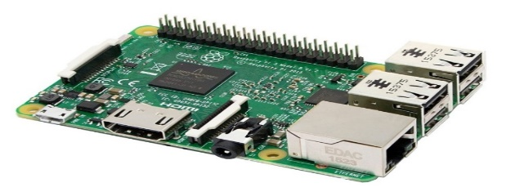

Figure 1: Raspberry Pi model B

Source: Adapted from [26]

2-The Raspberry Pi Camera Module v2

Raspberry Pi Camera Module v2 has 8-megapixel sensor. It is easily compatible with Raspberry Pi 3 model B.

The Camera Module will be used to take high-definition video and then to send that information to the Raspberry Pi module for further process. Also, it is easy to accommodate it in the stumps or in the circuit box behind the stumps.

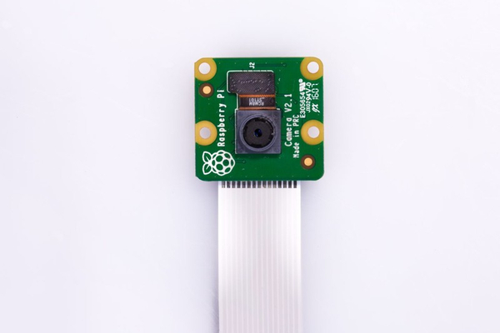

Figure 2: Raspberry Pi Camera module v2

Source: Adapted from [27]

**Process flow and Flowchart**

## This project mainly revolves around 4 techniques: -

### **Ball Detection**: Ball detection is done in multiple steps. The first step is to detect all the objects having nearly similar HSV color as that of the ball. Further steps include background subtraction and applying the bitwise AND operation on the result obtained from background subtraction and HSV color extraction technique.

### **Distance Calculation**: When the ball is closer to the camera, the pixel area occupied by the ball is larger. As the ball goes farther from the camera, the ball size will start to appear smaller and smaller, hence the pixel area enclosed by the object will keep reducing. Hence, distance is calculated based on the pixel area occupied by the ball in every frame.

### **Direction Assistance**: Direction Assistance is done with the help of the frame coordinate, the frame is divided into four sections (top left, top right, bottom left, bottom right) The direction of the approaching ball is decided based on the section in which the ball is lying.

### **Text to Speech**: The text is converted to an audio input using google text to speech. The message is further delivered to the players through earphones.

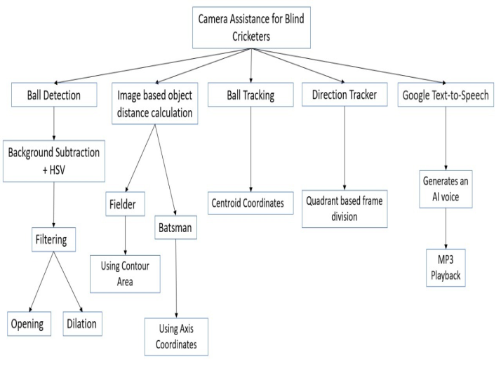

# IV- RESULTS/DISCUSSIONS



**Fig**: Ball Mask obtained after Bitwise And operation on HSV ball detection and Background subtraction results.

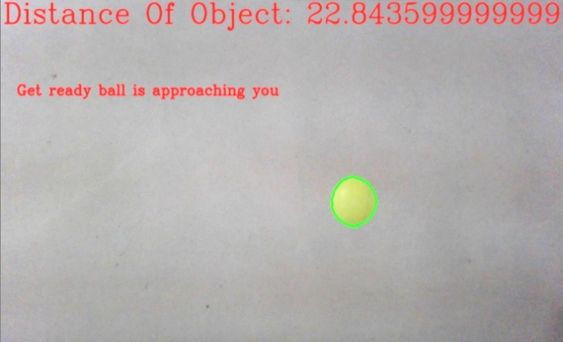

**Fig**: distance of the ball with notification and converts “get ready ball is approaching you” into speech.

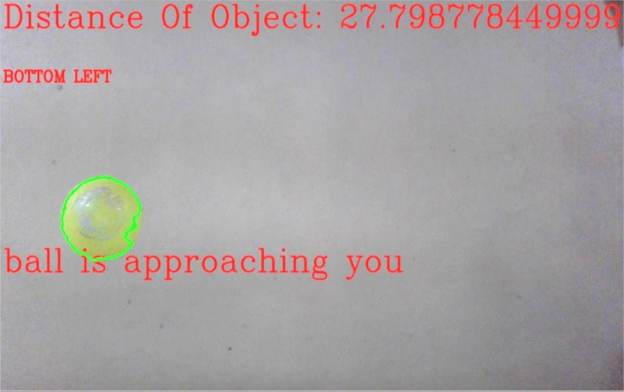

**Fig**: distance of the ball from the player and direction of approaching ball (Bottom left) notification to be converted from text to speech

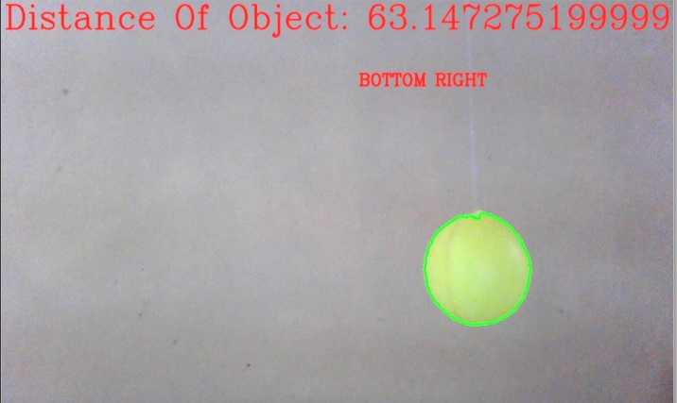

**Fig**: distance of the ball from the player and direction of approaching ball (Bottom right) notification to be converted from text to speech.

# V - Limitations

# 1 Real-time image processing applications require a stable and fast internet connection. This idea depends on how quick inputs are provided to the batsman and the fielders. Any lag in processing will result in a complete mess.

# 2 Players will require Bluetooth earphones to hear the processed instructions and data. But wearing them while constantly running might not be feasible

# 3 The ball detection algorithms are not very accurate and precise so the model may give false results

# . VI-Future Scope

# 1 Instead of a “play” call called by the bowler while releasing the ball the bowler can give a beep signal through the earphones to alert all the players in the field. This can be done with the help of the Distance calculation method used for Batsman.

# 2 Using the Distance calculation method for the batsman we will give the beep sound once again when the ball crosses half of the pitch so that the batsman will estimate the ball speed and therefore he/she can time the ball accordingly.

# 3 Before facing any delivery, knowledge about the field position is very important for both the batsman as well as bowler, so we can alert the batsman about the real-time field setting by converting that information into sound by using text to speech technique.

# 4 In the proposed system the hardware part plays a crucial role. Hence better hardware devices than Raspberry pi can be used to implement the algorithm to increase the overall accuracy and implementation speed of our algorithm

# VII-Conclusion

Cricket is one of the most popular games in the world, there are a lot of advancements in cricket in recent years, this paper focused on improving blind cricket using OpenCV, raspberry pi, etc. Every game has its own set of rules and challenges. Similarly, blind cricket is based on the hearing capacity of the players, we didn’t want to kill the spirit of the game so while proposing the advancements, the appropriate care has been taken. We hope that these advancements will make the game even more interesting and therefore increase the popularity of this underrated sport

VIII-Acknowledgment

Our sincere appreciation goes to staff members and out guide of the Department of Electronics and Telecommunication, Vishwakarma Institute of Technology, Pune for the successful completion of this project.

IX-References

1. Han, X., Gao, Y., Lu, Z., Zhang, Z., &Niu, D. (2015). Research on Moving Object Detection Algorithm Based on Improved Three Frame Difference Method and Optical Flow. 2015 Fifth International Conference on Instrumentation and Measurement, Computer, Communication and Control
2. Format: P.K. Thadagoppula, V. Upadhyaya, “Speed Detection

using Image Processing,” 2016 International Conference on Computer, Control, Informaticsand its Applications(IC3INA), Tangerang, Indonesia,2016, pp.1-6, doi: 10.1109/IC3INA.2016.7863015

1. Bourbakis, N. (2008). Automatic Image-to-Text-to-Voice Conversion for Interactively Locating Objects inHome Environments. 2008 20th IEEE International Conference on Tools with Artificial
2. Fares Jalled, ́ Moscow Institute of Physics & Technology, Department of Radio Engineering & Cybernetics Ilia Voronkov, Moscow Institute of Physics & Technology, Department of Radio Engineering & Cybernetics , 26 Nov 2016
3. Fares Jalled, ́ Moscow Institute of Physics & Technology, Department of Radio Engineering & Cybernetics Ilia Voronkov, Moscow Institute of Physics & Technology, Department of Radio Engineering & Cybernetics , 26 Nov 2018
4. :MArchana,MKalaisevi,“ObjectDetectionand

TrackingBasedonTrajectoryinBroadcastTennisVideo”2015ProcediaComputer Science58:225-232,DOI:10.1016/j.procs.2015.08.060

1. Yi-You Hou, Sz-Yu Chiou and Ming-Hung Lin “Real-time detection and tracking for moving objects based on computer vision method” 2017 2nd International Conference on Control and Robotics Engineering, Bangkok, Thailand 2017, pp.1-5, doi: 10.1109/ICCRE.2017.7935072
2. Saleh Shadi, Saleh Hadi, Mohammad Amin Nazari, Wolfram Hard Outdoor Navigation for Visually Impaired based on Deep Learning All content following this page was uploaded by Shadi Saleh on 19 November 2019.
3. Saleh Shadi, Saleh Hadi, Mohammad Amin Nazari, Wolfram Hard Outdoor Navigation for Visually Impaired based on Deep Learning All content following this page was uploaded by Shadi Saleh on 19 November 2019.
4. Institute of Electronics and Computer Science Dzerbenesst. 14, LV–1006 Riga, Latvia, phone: +371 7554500; e–mail: mednieks@edi.lv , ISSN 1392 – 1215 , 2009. No. 4(92)
5. A SURVEY ON MOVING OBJECT TRACKING USING IMAGE PROCESSING 2017 11th International Conference on Intelligent Systems and Control (ISCO)
6. Proceedings of 2018 IEEE International Conference on Mechatronics and Automation August 5 - 8, Changchun, China. College of Automation, Harbin Engineering University, Harbin, 150001, China
7. 2015 International Conference on Industrial Instrumentation and Control (ICIC) College of Engineering Pune, India. May 28-30, 2015
8. T.S. Nachiar, Dr.M.Arunachalam, P.R.Hemalatha, Dr.R.Aghila, R.T.Subhalakshmi, “An Obstacle Detection And Distance Sensing Algorithm For Visually Impaired Persons” ,2019 INTERNATIONAL JOURNAL OF SCIENTIFIC & TECHNOLOGY RESEARCH VOLUME 8 , India, pp. 1-4, doi: 10 OCTOBER 2019
9. N.A.Othman, M.U.Salur, M.Karakose, I.Aydin, “An Embedded Real-Time Object Detection and Measurement of its Size “ 2018, International Conference on Artificial Intelligence and Data Processing (IDAP) 2018, Turkey, pp. 1-4, doi: 10.1109/IDAP.2018.8620812
10. Ashfaqur Rahman, Abdus Salam, Mahfuzul Islam, and ParthaSarker .An Image Based Approach to Compute Object Distance International Journal of Computational Intelligence Systems, Vol.1, No. 4 (December, 2008),
11. Pritam Das, Ranjit Ghoshal, Dipak Kumar Kole, Rabindranath Ghosh Measurement of Displacement and Velocity of a Moving Object from Real Time Video International Journal of Computer Applications (0975 – 8887) Volume 49– No.13, July 2012
12. Zhou,LeiXie,“Detectionofballhitsinatennisgameusingaudioandvisual
13. A.Vishwakarma, A. Khare, “Moving Object Tracking System Using Morphological Image Processing”, “International Journal of Computer Sciences and Engineering” 2018, India,
14. Mohana,“RealTimeObjectDetectionandTrackingUsingDeepLearningandOpenCV”,2018DOI:10.1109/ICIRCA.2018.859Conference:2018International
15. Sharma,“Cricketumpireassistanceandballtrackingsystemusingasinglesmartphonecamera”,2017DivisionofComputerEngineering,NetajiSubhasInstitute
16. Pinquier,“Pyc2Sound:aPythontooltoconvertimagesintosound”,2015DOI: 10.1145/2814895.2814912Conference:theAudioMostly2015.
17. Lafortune, Eric P. and Willems, Yves D. Bi-directional path tracing. Proceedings of Third International Conference on Computational Graphics and Visualization Techniques (Compugraphics '93). Alvor, Portugal
18. Gavrila, D. M., &Philomin, V. (1999). Real-time object detection for “smart” vehicles. Proceedings of the Seventh IEEE International Conference on Computer Vision. doi:10.1109/iccv.1999.791202
19. Porikli, F. (2006). Achieving real-time object detection and tracking under extreme conditions. Journal of Real-
20. <https://5.imimg.com/data5/DC/UX/MY-73395804/raspberry-pi-3-model-b-inbult-bluetooth-and-wifi-500x500.jpg>
21. https://www.raspberrypi.org/homepage-9df4b/static/621b26de7977c5b8d765b3003b341a49/8924f/68fe7e4cb53767ad6c033bf3b46da3452188a24a_pi-camera-front-1-1426x1080.jpg